Page 17

Location Map

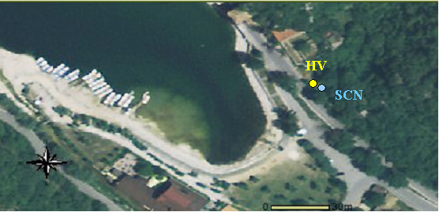

Table

Max. HVSR at 3.59 ± 0.28 Hz. (in the range 0.0 - 20.0 Hz).

Criteria for a reliable HVSR curve
[All 3 should be fulfilled]

f₀ > 10 / L_{w} | 3.59 > 0.50 | OK
n_{c}(f₀) > 200 | 4312.5 > 200 | OK
σ_{A}(f) < 2 for 0.5f₀ < f < 2f₀ if f₀ > 0.5Hz  σ_{A}(f) < 3 for 0.5f₀ < f < 2f₀ if f₀ < 0.5Hz | Exceeded 0 out of 174 times | OK

Criteria for a clear HVSR peak
[At least 5 out of 6 should be fulfilled]

Exists f ⁻ in [f₀/4, f₀] | A_{H/V}(f ⁻) < A₀ / 2 |  |  | NO
Exists f ⁺ in [f₀, 4f₀] | A_{H/V}(f ⁺) < A₀ / 2 | 14.281 Hz | OK
A₀ > 2 | 3.15 > 2 | OK
f_{peak}[A_{H/V}(f) ± σ_{A}(f)] = f₀ ± 5% | |0.039| < 0.05 | OK
σ_{f} < ε(f₀) | 0.14016 < 0.17969 | OK
σ_{A}(f₀) < θ(f₀) | 0.2824 < 1.58 | OK

Chart

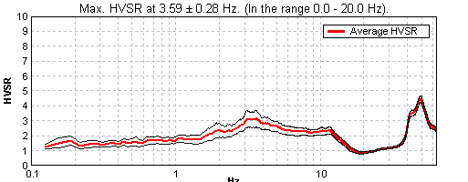

f₀ = 3.6 Hz

Date of measurements = 30/07/2009
Page 11

Chart1 (metodo ESAC)

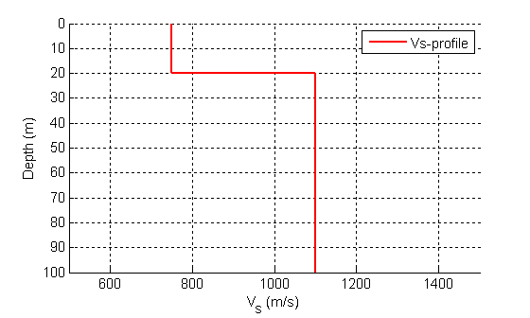

Table 1

Tickness (m) | S-Velocity (m/s)
20 | 750
? | 1100

Page 19

Based on in-situ measurements
Method = ES
Vs30 = 840 m/s
Soil Class = A
Topography classification = T4

Page 20

Vs30 = 840 m/s
Site Class = A
Depth to bedrock = 20 m
Average Vs to bedrock = 750 m/s
f₀ from microtremors = 3.6 Hz

