Page 17

Location Map

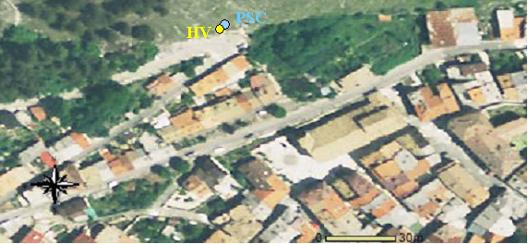

Table

Max. HVSR at 4.28 ± 0.48 Hz. (in the range 0.0 - 20.0 Hz).

Criteria for a reliable HVSR curve
[All 3 should be fulfilled]

f₀ > 10 / L_{w} | 4.28 > 0.50 | OK
n_{c}(f₀) > 200 | 5137.5 > 200 | OK
σ_{A}(f) < 2 for 0.5f₀ < f < 2f₀ if f₀ > 0.5Hz  σ_{A}(f) < 3 for 0.5f₀ < f < 2f₀ if f₀ < 0.5Hz | Exceeded 0 out of 206 times | OK

Criteria for a clear HVSR peak
[At least 5 out of 6 should be fulfilled]

Exists f ⁻ in [f₀/4, f₀] | A_{H/V}(f ⁻) < A₀ / 2 | 1.313 Hz | OK
Exists f ⁺ in [f₀, 4f₀] | A_{H/V}(f ⁺) < A₀ / 2 | 12.5 Hz | OK
A₀ > 2 | 2.59 > 2 | OK
f_{peak}[A_{H/V}(f) ± σ_{A}(f)] = f₀ ± 5% | |0.05566| < 0.05 |  | NO
σ_{f} < ε(f₀) | 0.23827 < 0.21406 |  | NO
σ_{A}(f₀) < θ(f₀) | 0.0925 < 1.58 | OK

Chart

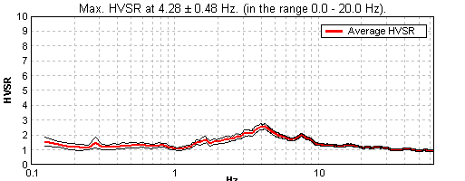

f₀ = 4.3 Hz

Date of measurements = 30/07/2009
Page 11

Chart1 (metodo ESAC)
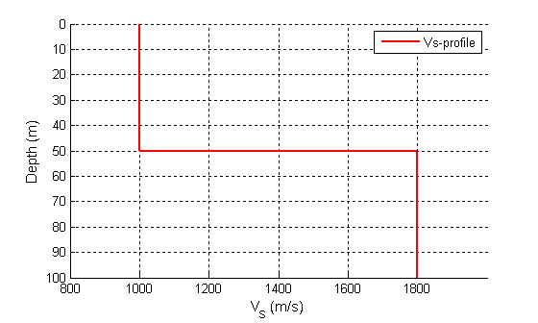

Table 1

Tickness (m) | S-Velocity (m/s)
50(43-64) | 1000
? | 1800

Page 19

Based on in-situ measurements
Method = ES
Vs30 = 1000 m/s
Soil Class = A
Topography classification = T3

Page 20

Vs30 = 1000 m/s
Site Class = A
Depth to bedrock = 0 m
Average Vs to bedrock = 0 m/s
f₀ from microtremors = 4.3 Hz

